St. Mary’s Health Professions Academy
Student Application

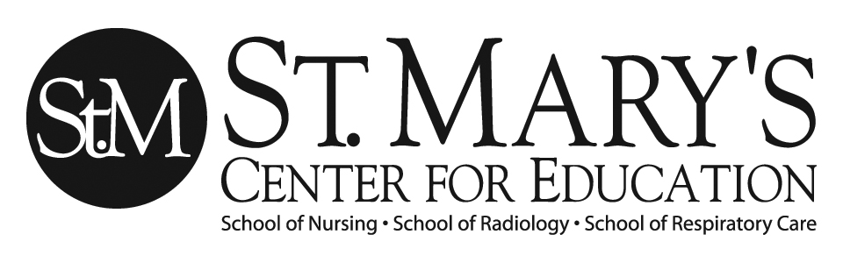
Tenth and eleventh grade students in tri-state area who are interested in a health care career will be considered for the St. Mary’s Health Professions Academy. The Academy will be held on May 25th and 26th at the St. Mary’s Center for Education. Only complete applications will be accepted. Applications must be received by May 1, 2023.

Application Requirements Include:

- You must have at least an 80% or 3.0 current overall grade average
- You must be a current high school student attending 10th or 11th grade

I. STUDENT INFORMATION please type or print all responses legibly in ink
____________________________________________________________________________________________________________
Last Name First Name Middle Initial Nickname

_______________________________________________________________________________________________________________________________________
Birth Date (Month/Day/Year) Home Phone Cell Phone Email Address

_______________________________________________________________________________________________________________________________________
Mailing Address PO Box/Rural Route

_______________________________________________________________________________________________________________________________________
City State County Zip Code

T-Shirt Adult Size: (please circle one) Gender: Race: (circle one or more)
XS (4/6) Male Caucasian
S (6/7) American Indian/Alaskan Native
M (8-10) Female African American
L (12/14) Asian
XL (16) Hispanic (non-Caucasian)
2XL Pacific Islander
3 XL Mixed Race

Medical Problems and/or Medications:

____________________________________________________________________________________________________________

II. SCHOOL INFORMATION

___________________________________________________________________________________________________________
Name of School Currently Attending Current Grade in School

______________________________________________________________________________________________________________________________________
School Address City State

______________________________________________________________________________________________________________________________________
County Zip Code Phone (Including Area Code)

______________________________________________________________________________________________________________________________________

Current overall grade average (Must be at least 80% or 3.0 GPA)

III. INFORMATION TO BE COMPLETED BY SCHOOL COUNSELOR OR TEACHER

__________________________________________________________________________________________
School Counselor/Teacher Name (print) Title Phone Number

I certify that the student applicant has a current overall grade average of __________ %. (Must be at least 80% or 3.0 GPA)

________________________________________________________________________________________________________________________
School Counselor/Teacher Signature Date

IV. STUDENT AND PARENT SIGNATURES

I certify that the information contained in this completed application is accurate. I certify that I wrote the essay I am submitting with this application. I understand that falsification of any information on this application may result in my being disqualified from the application process and/or the St. Mary’s Health Professions Academy. If I am selected for the Academy and choose to participate, I agree to abide by all Academy rules and guidelines and participate in all of the scheduled activities.

________________________________________________________________________________________________________________________
Student Signature Date

I have read the application and certify that the information is accurate. I give my permission for my child to apply and participate in the St. Mary’s Health Professions Academy. If my child is accepted and participates, I agree to support him/her throughout the program and will willingly respond as requested to the St. Mary’s Health Professions Academy surveys regarding my child and his/her participation. I hereby agree that all participating entities will not be held responsible for any injury or accident that might occur through participation in the St. Mary’s Health Professions Academy; in addition, any medical expenses incurred as a result of such injury or accident will be my personal responsibility.

________________________________________________________________________________________________________________________
Parent/Guardian Signature Date

In case of medical emergency, staff must be able to contact a parent/guardian or other emergency contact authorized to approve medical treatment for the student. Please provide current, accurate information and assure that you and/or a back-up contact are always available while the student is participating in Academy activities.

____________________________________________________ ________________________________________________________
Parent/Guardian Name (print) Back-Up Contact Name (print)
____________________________________________________ ________________________________________________________
Address Relationship to Student
____________________________________________________ ________________________________________________________
Home Phone Cell Phone Work Phone Home Phone Cell Phone Work Phone

Please Return Application to: For Questions and Concerns:

Dr. Joey Trader, EdD, MSN, RN, CNE Paula Cremeans
Vice President Schools of Nursing and Health Professions Administrative Secretary
Director School of Nursing St. Mary’s Center for Education
St. Mary's Center for Education 2900 First Avenue
2853 5th Avenue Huntington, WV 25702
Huntington, WV 25702 Office: 304-526-1426
Office: 304-526-1416
Fax: 304-399-1981

Completed Application Must Be Returned by May 1, 2023

St. Mary’s Health Professions Academy

Health Assessment Form

Instructions to Parent/Guardian: Please fill out your child’s medical form and include it with the other forms to be returned to the Academy.

Student’s Name: ___________________________________________________ DOB: ________________

HEALTH ASSESSMENT:
Complete each line | Yes | No | Comments
Vision / Wears Corrective Lenses
Hearing / Wears Hearing Aid
Skin Disorder
Special Nutritional Requirements
Neurological Disorders (such as Epilepsy)
Spinal Disorder
Allergies (Medication, Food, Latex or Environmental)
Digestive Disorder
Muscular Disorder
Asthma
Heart Problems
Tobacco Use
Pregnant

Chronic illness that may require medication or special accommodations?_______________________
If yes, please explain:______________________________________________________________________
__________________________________________________________________________________________

Parent Signature: ________________________________________________ Date: __________________

Consent to Photograph

Name: (please print)

_____________________________________________________________________________
Last First Middle

I hereby give consent to St. Mary’s Medical Center to take moving and/or still photographs and/or sound/video recordings for any and all educational and/or marketing purposes that the hospital may deem proper of (check appropriate person):

◻ Son ◻ Daughter
◻ Other individual for whom I am authorized to provide consent

Made on (date pictures taken): May 25th and May 26th, 2023

Used for: St. Mary’s Center for Education

I understand that these photographs and/or sound/video recordings will be used on behalf of St. Mary’s Medical Center for the above stated purposes. I further relinquish all right, title and interest in said moving and/or still photographs and sound/video recordings.

I also state that I have signed this form PRIOR to the taking of any photographs and/or sound/video recordings.

Participant’s Signature: _____________________________________ Date: _______________

Parent’s Signature: _____________________________________________________________

St. Mary’s Medical Center for Education
2853 5th Ave – Huntington, WV – 25702 (304) 526-1426

